ID HUB Flash Replacement Project

Table of Contents

LOGIN 4

Step 1: Login 4

REQUESTOR WORKLIST TABS/SUBTABS 6

CURRENT REQUEST SUBTAB 6

Step 2: Requestor Worklist 🡪Current Request Tab Loads 6

Step 3: Downloads Documents from Library 8

Step 4: Bulk Import as Group 10

Step 5: Edit Request 13

Step 6: Cancel Changes 15

Step 7: Save Changes to Request 17

Step 8: Upload Documentation 19

Step 9: Submit Request 21

SEARCH REQUEST SUBTAB 23

Step 10: Search Request 23

Step 11: View Documents 25

Step 12: Edit Request 27

Step 13: Save Changed Request 29

Step 14: Submit Request 31

SERVICE DESK REVIEWER TAB 33

Step 15: Service Desk Reviewer Tab 33

Step 16: Service Desk Reviewer View Documents 35

Step 17: Under Review 37

Step 18: Cancel Review 39

Step 19: Reject Request 41

Step 20: Accept Request 43

MANAGE USERS TAB 45

Step 21: Manage Users Tab 45

Step 22: Add New User 47

Step 23: Edit Users 49

Step 24: Cancel User Changes 51

Step 25: Save User 53

Step 26: Activate User 55

ADMIN TABS/SUBTABS 57

DEPARTMENTS SUBTAB 57

Step 27: Departments Tab 57

Step 28: Edit Department 59

Step 29: Cancel Department Edit 61

Step 30: Save Department 63

Step 31: Delete Department 65

LOCATIONS SUBTAB 67

Step 32: Locations Tab 67

Step 33: Edit Locations 69

Step 34: Cancel Location Edit 71

Step 35: Save Location 73

Step 36: Delete Location 75

USER TYPES SUBTAB 77

Step 37: User Types Tab 77

Step 38: Edit User Types 79

Step 39: Cancel User Types Edit 81

Step 40: Save User Types 83

Step 41: Delete User Types 85

TITLE SUBTAB 87

Step 42: Title Tab 87

Step 43: Edit Title 89

Step 44: Cancel Title Edit 91

Step 45: Save Title 93

Step 46: Delete Title 95

# LOGIN

### Step 1: Login

#### Example Screen:

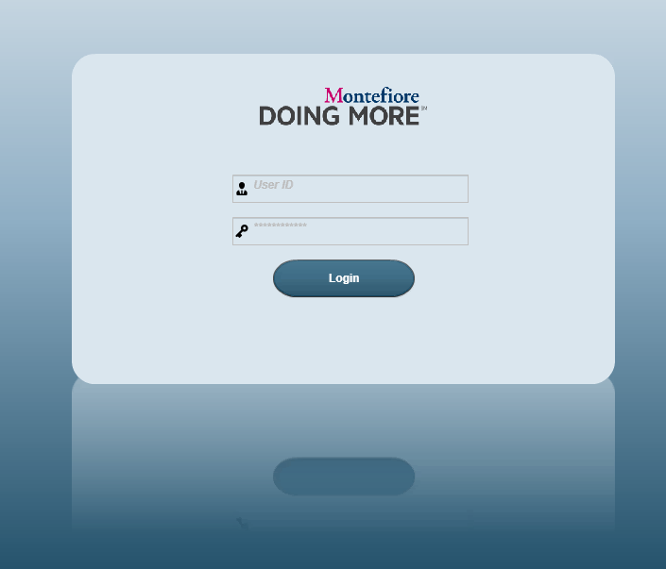

#### Request:

#### Response:

# REQUESTOR WORKLIST TABS/SUBTABS

## CURRENT REQUEST SUBTAB

### Step 2: Requestor Worklist 🡪Current Request Tab Loads

#### Example Screen:

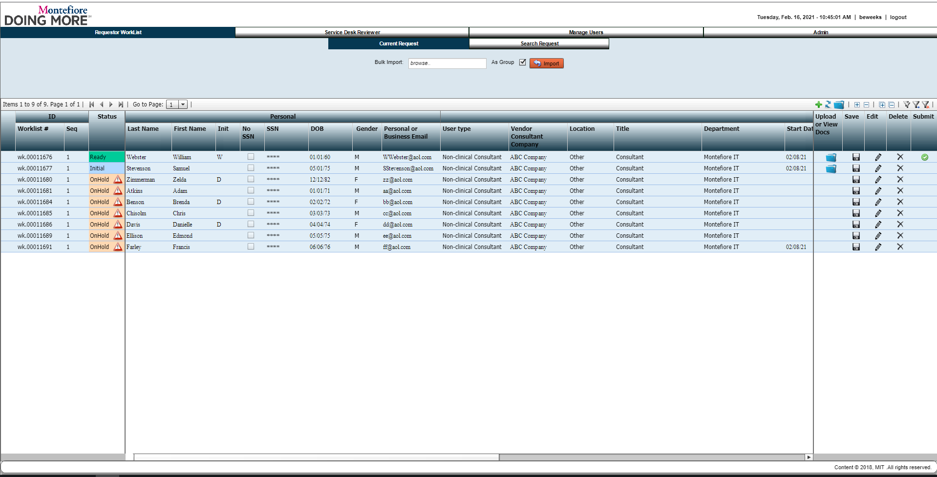

#### Request:

#### Response:

### Step 3: Downloads Documents from Library

#### Example Screen:

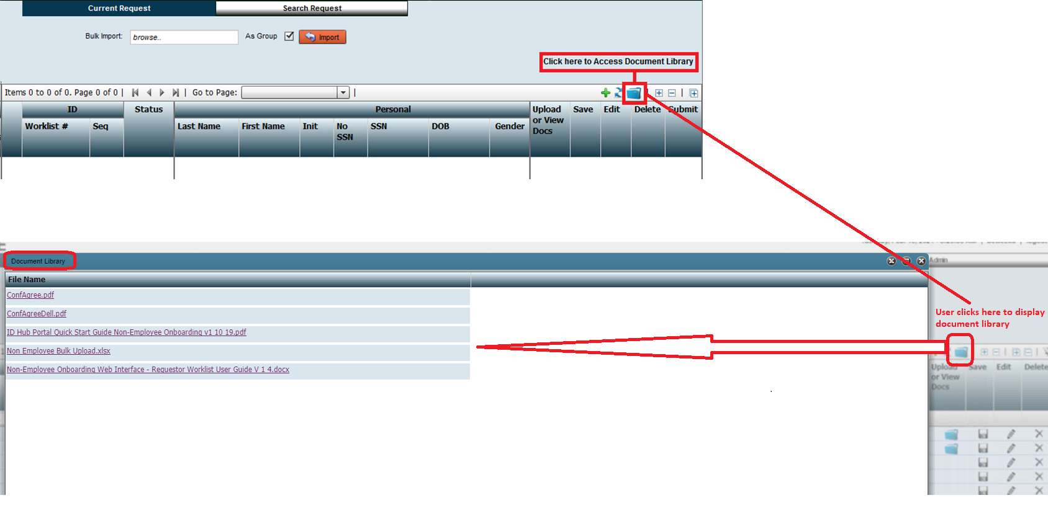

#### Request:

#### Response:

### Step 4: Bulk Import as Group

#### Example Screen:

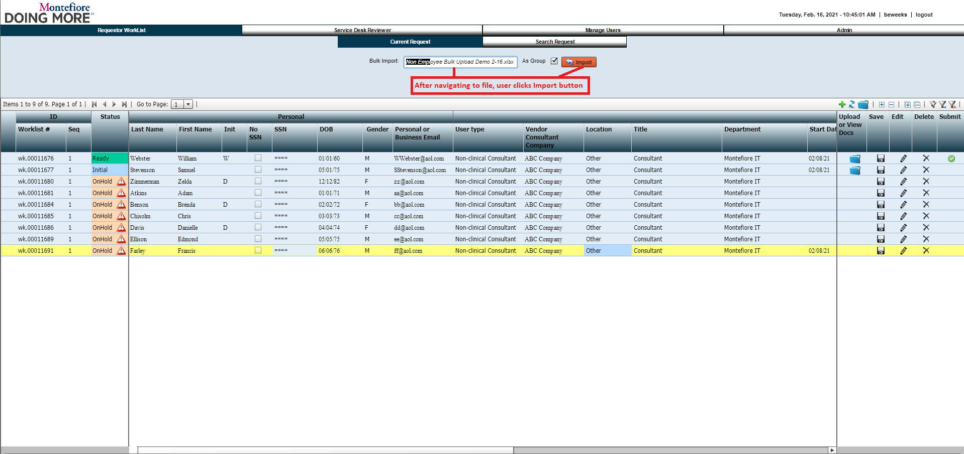

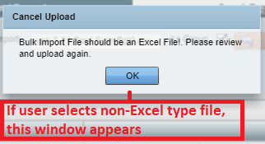

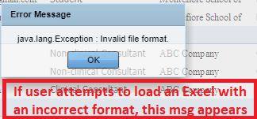

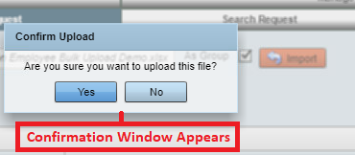

Screen Shot After Bulk Import is Successfully Completed:

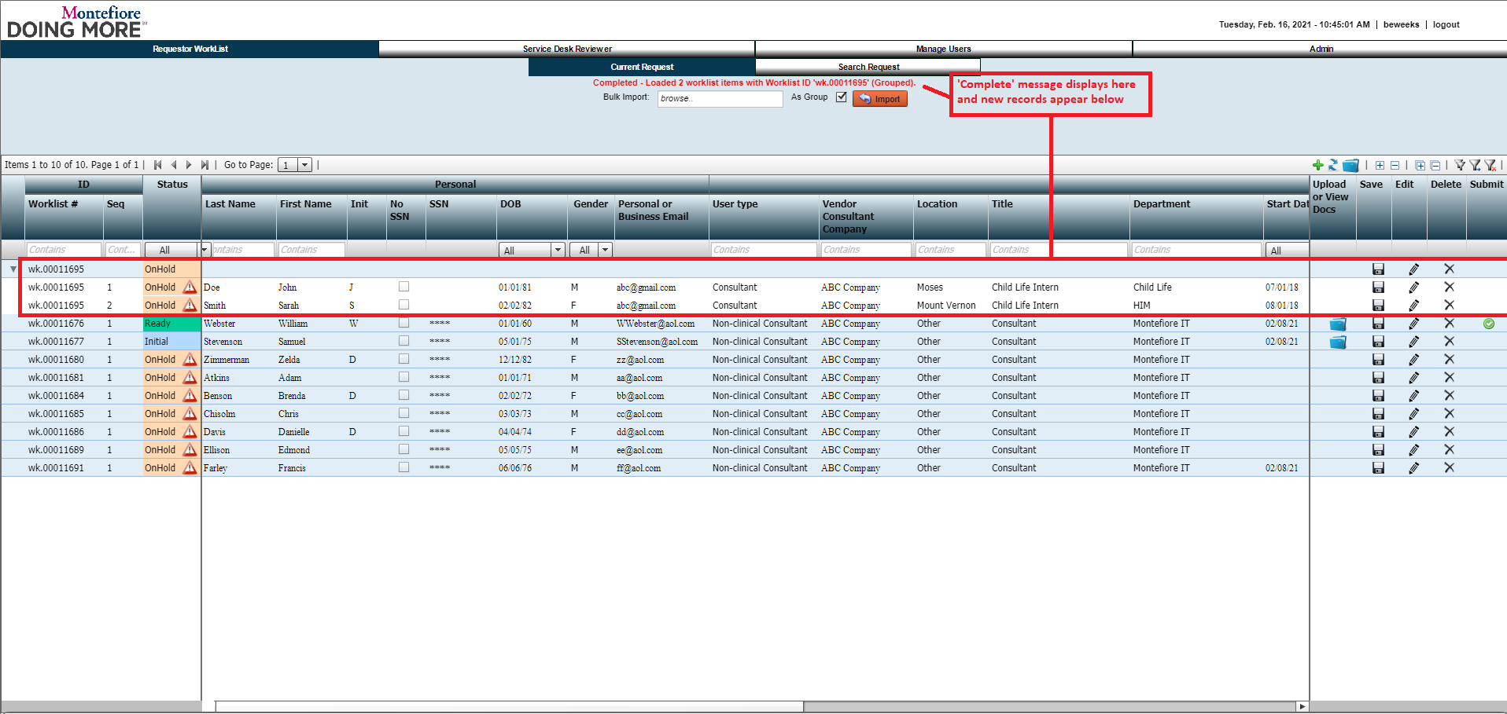

#### Request:

#### Response:

### Step 5: Edit Request

#### Example Screen:

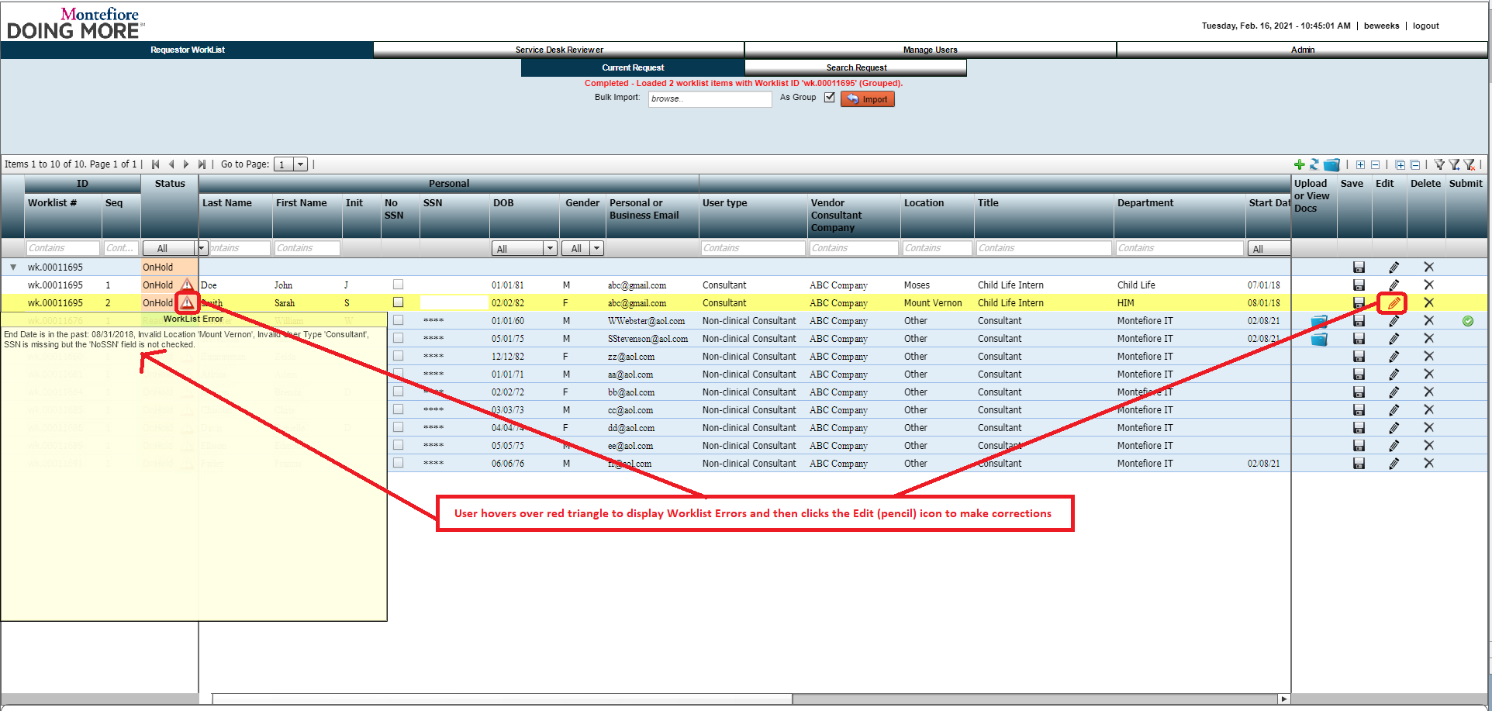

#### Request:

#### Response:

### Step 6: Select Volunteer for User Type

#### Example Screen:

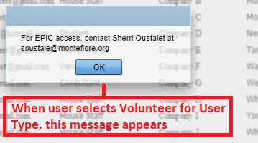

#### Request:

#### Response:

### Step 7: Cancel Changes

#### Example Screen:

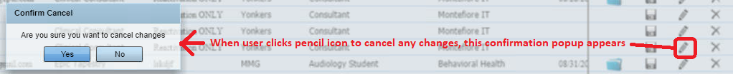

#### Request:

#### Response:

### Step 8: Save Changes to Request

#### Example Screen:

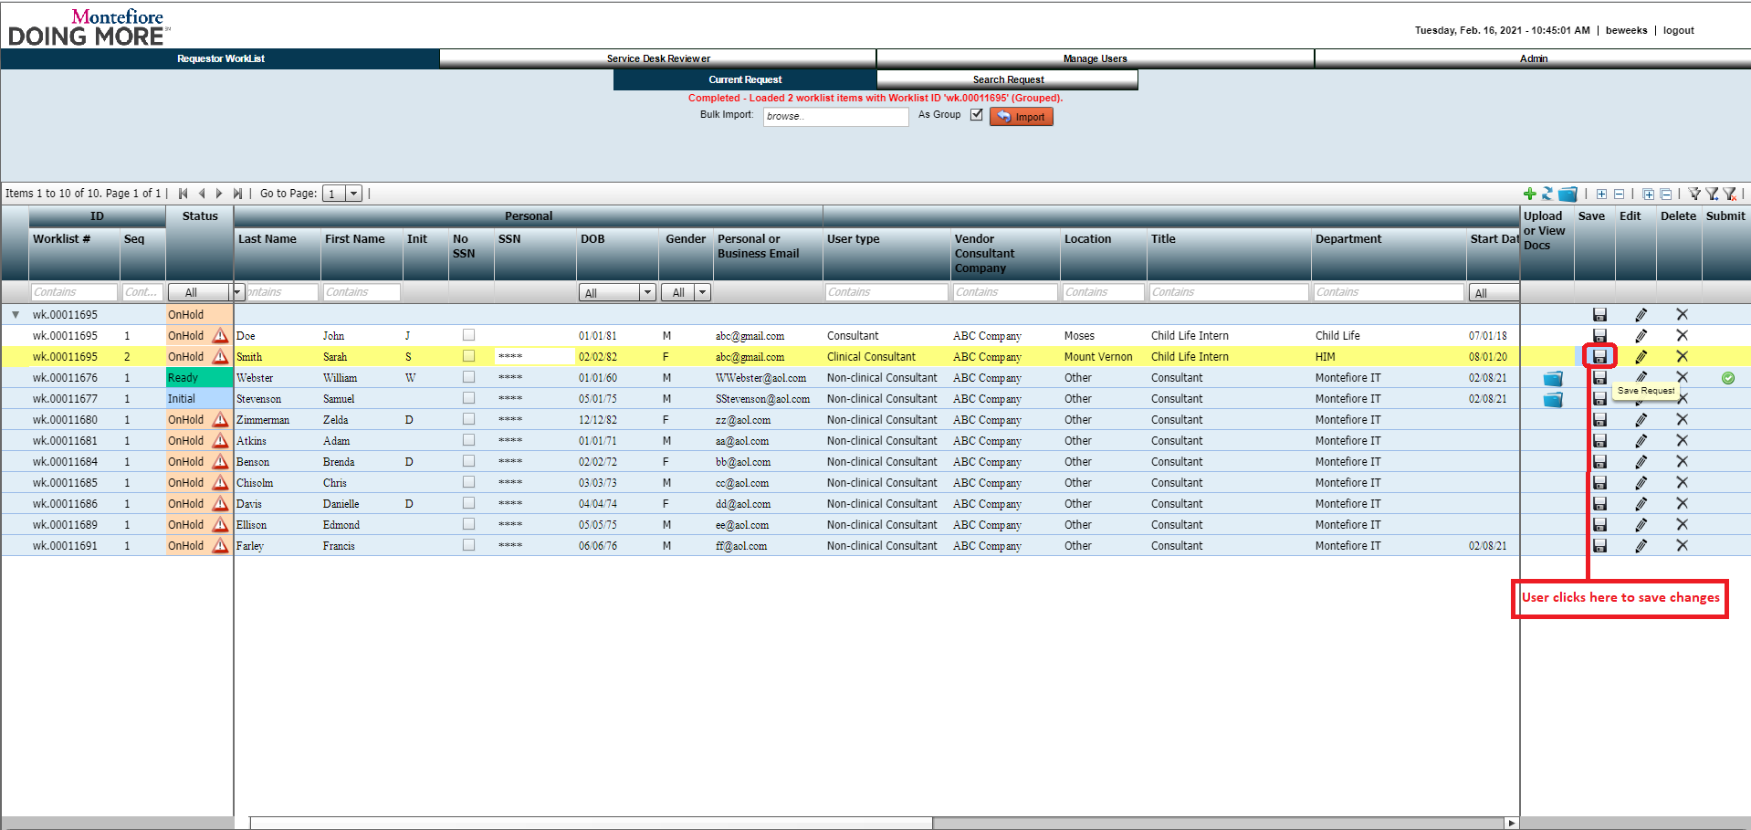

#### Request:

#### Response:

### Step 9: Upload Documentation

#### Example Screen:

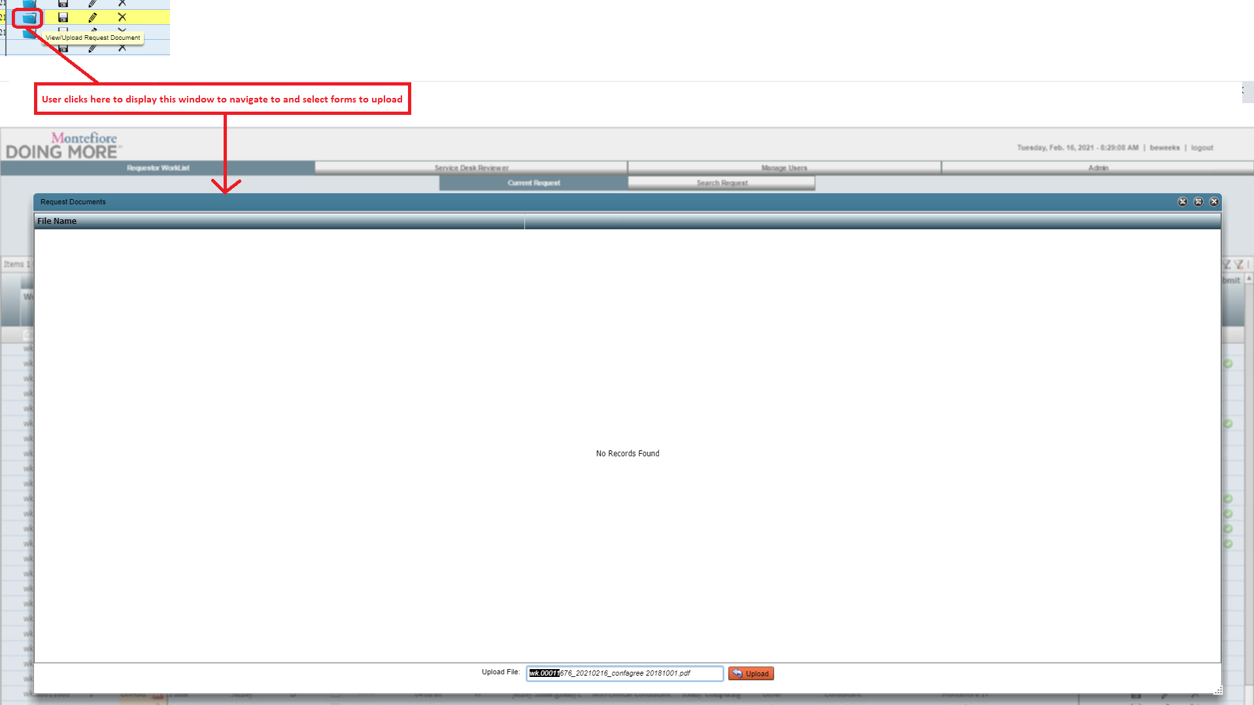

#### Request:

#### Response:

### Step 10: Confirm Upload

#### Example Screen:

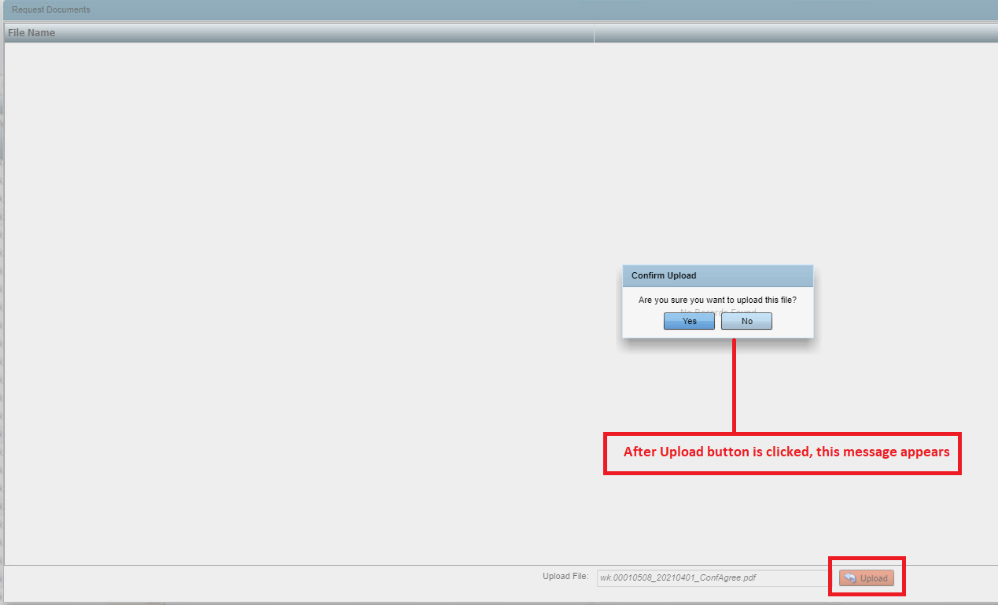

#### Request:

#### Response:

### Step 11: Confirm Delete

#### Example Screen:

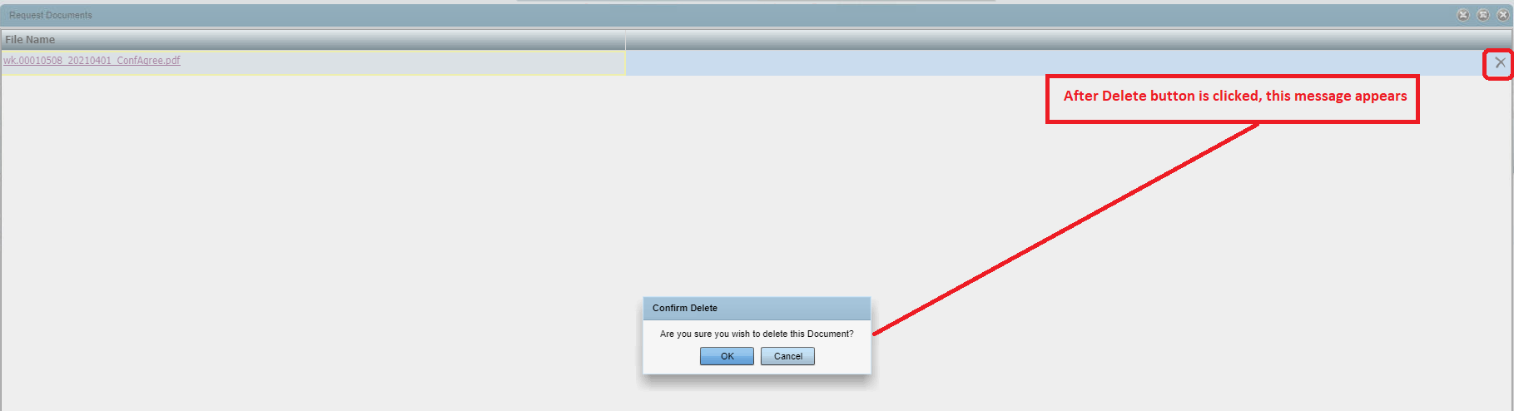

#### Request:

#### Response:

### Step 12: Submit Request

#### Example Screen:

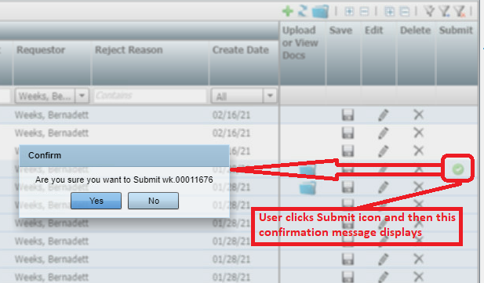

#### Request:

#### Response:

## SEARCH REQUEST SUBTAB

### Step 13: Search Request

#### Example Screen:

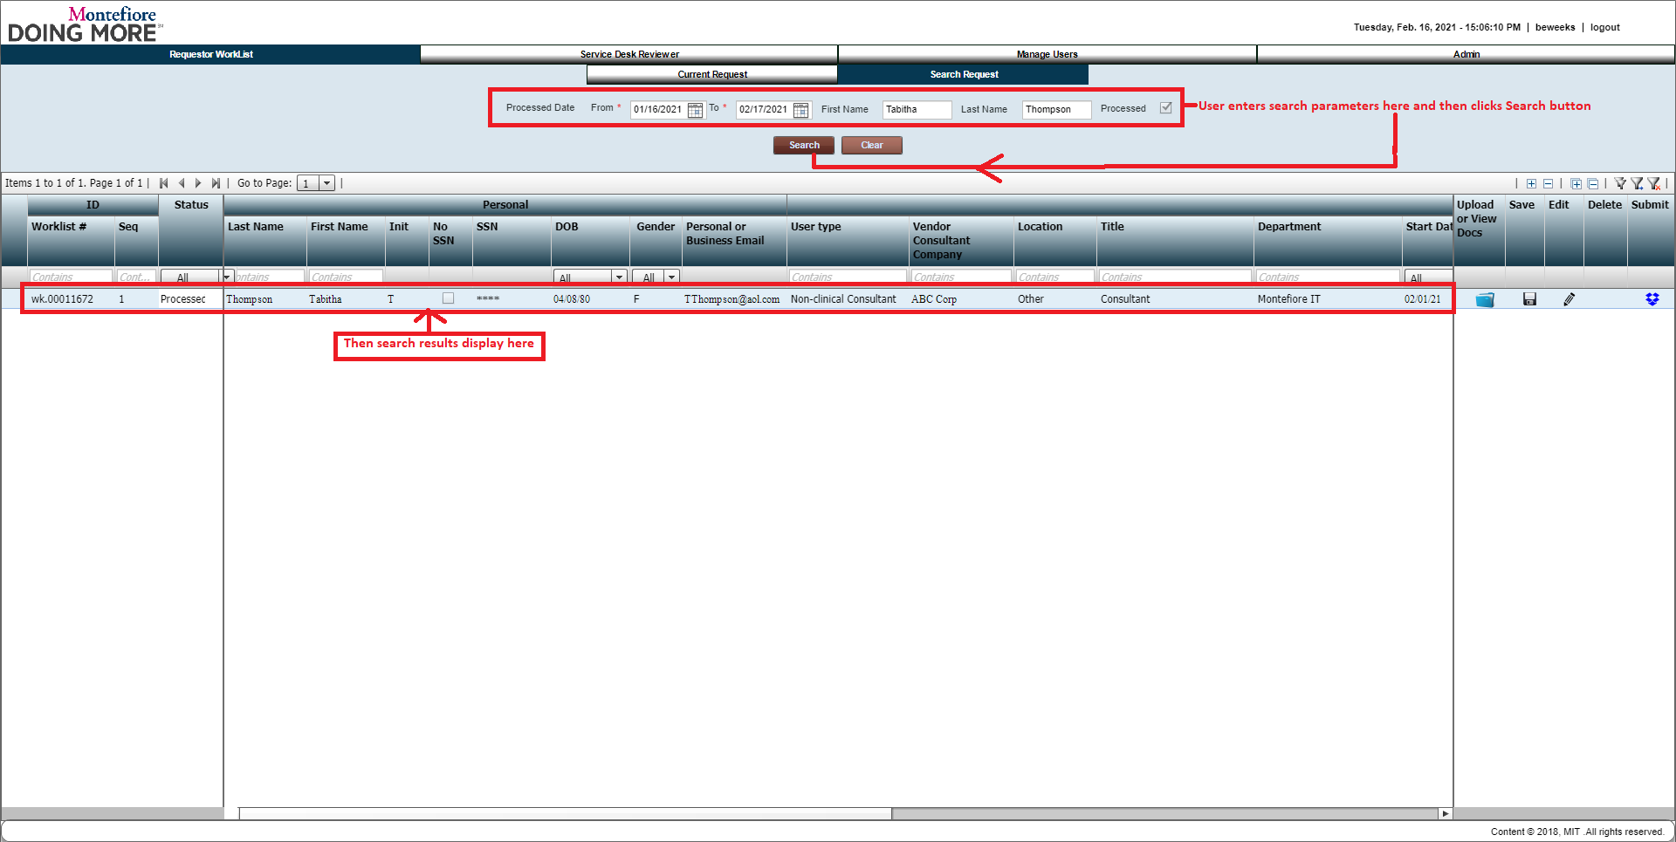

#### Request:

#### Response:

### Step 14: View Documents

#### Example Screen:

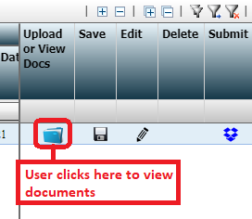

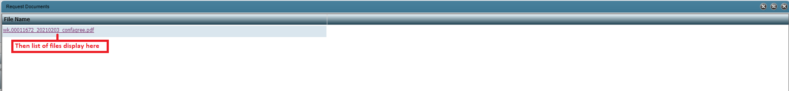

#### Request:

#### Response:

### Step 15: Edit Request

#### Example Screen:

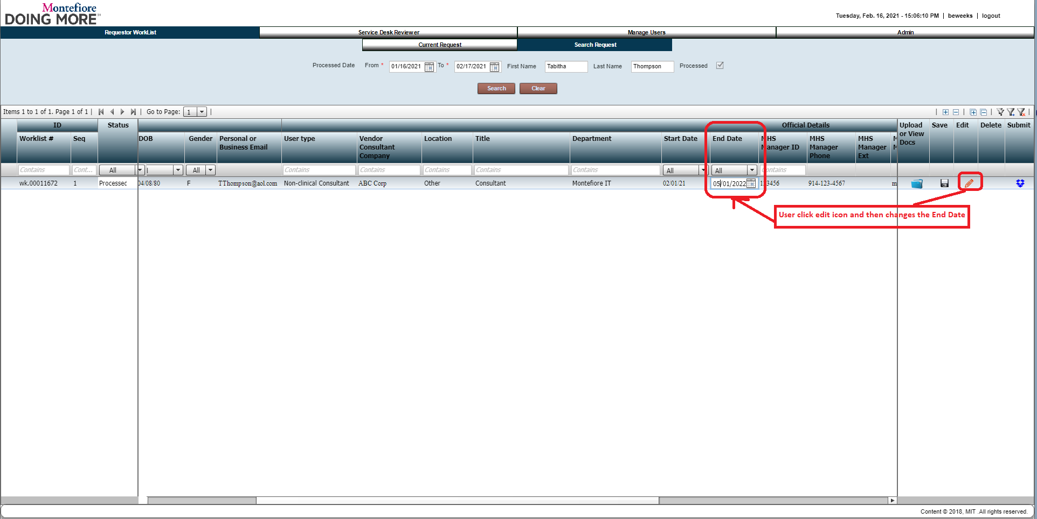

#### Request:

#### Response:

### Step 16: Cancel Changes

#### Example Screen:

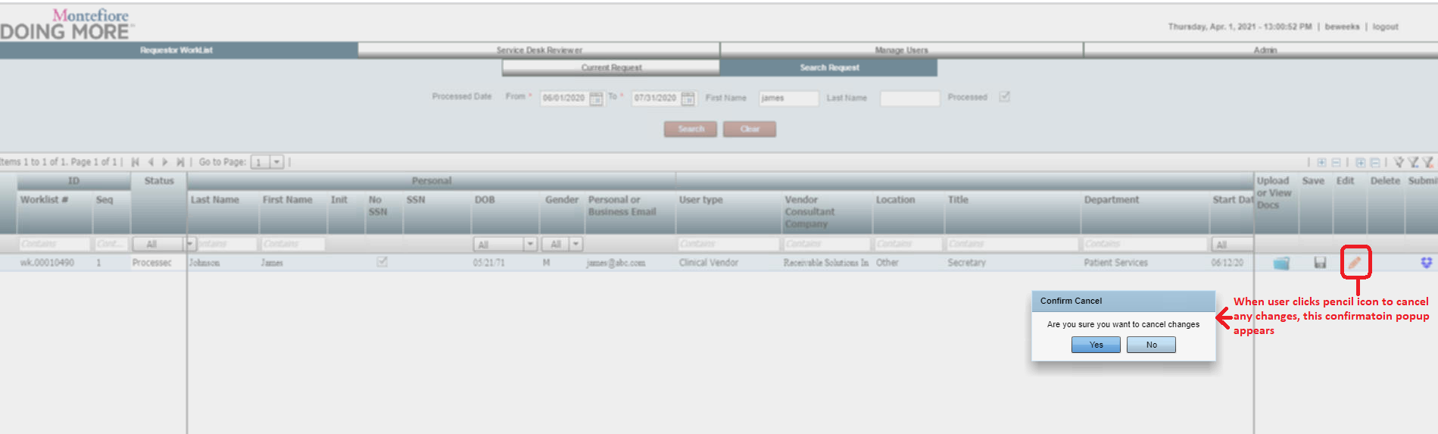

#### Request:

#### Response:

### Step 17: Save Changed Request

#### Example Screen:

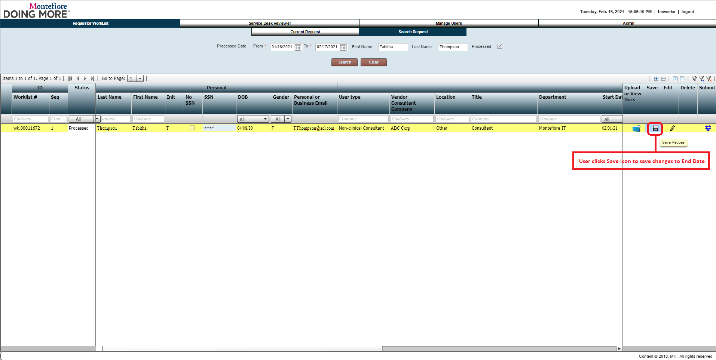

#### Request:

#### Response:

### Step 18: Submit Request

#### Example Screen:

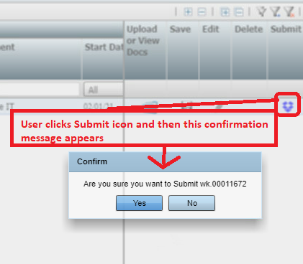

#### Request:

#### Response:

# SERVICE DESK REVIEWER TAB

### Step 19: Service Desk Reviewer Tab

#### Example Screen:

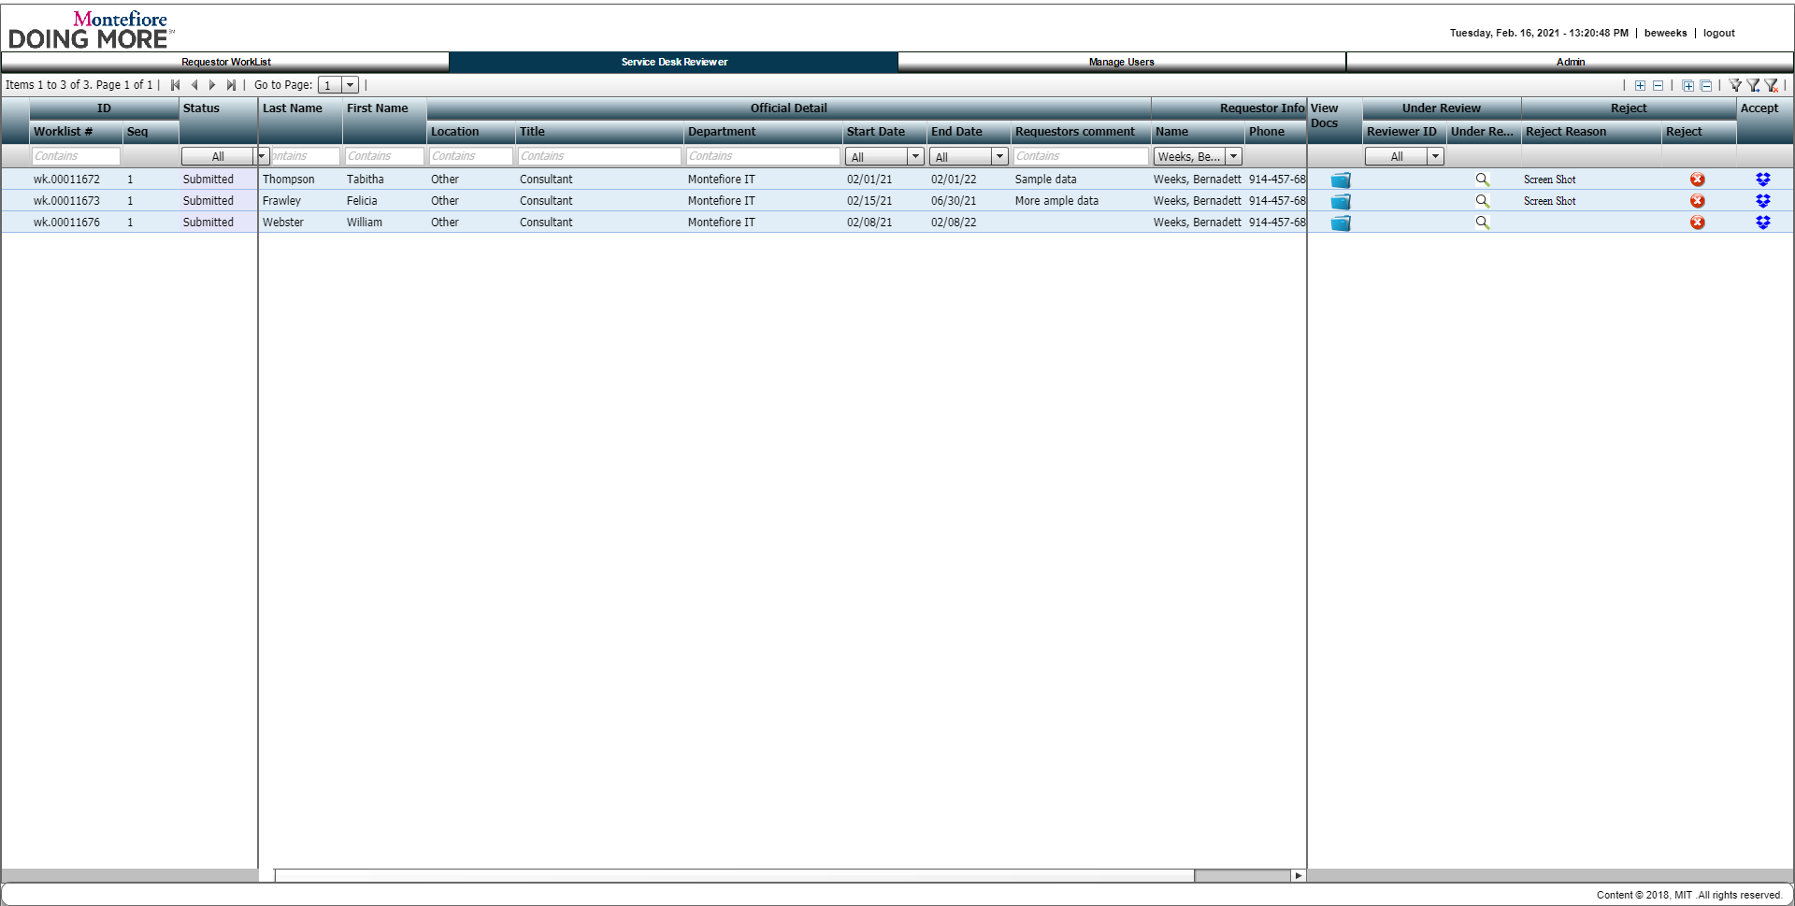

#### Request:

#### Response:

### Step 20: Service Desk Reviewer View Documents

#### Example Screen:

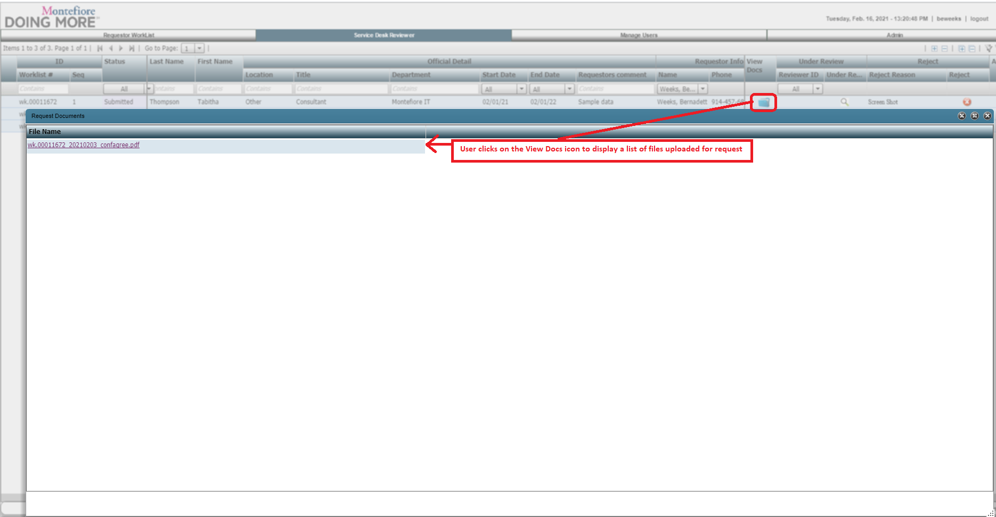

#### Request:

#### Response:

### Step 21: Under Review

#### Example Screen:

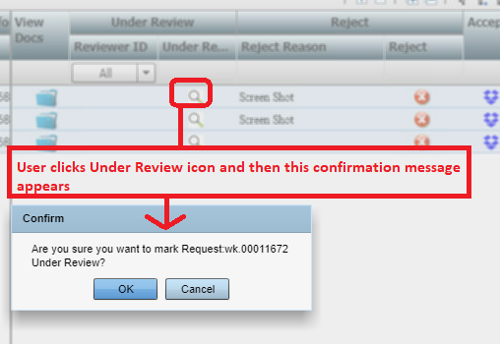

#### Request:

#### Response:

### Step 22: Cancel Review

#### Example Screen:

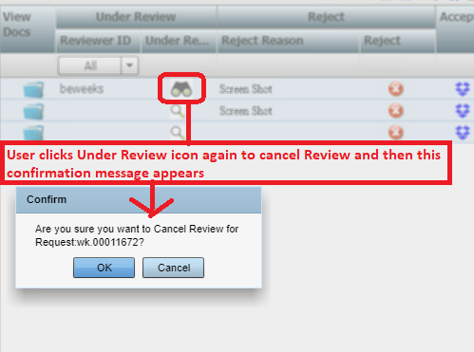

#### Request:

#### Response:

### Step 23: Reject Reason

#### Example Screen:

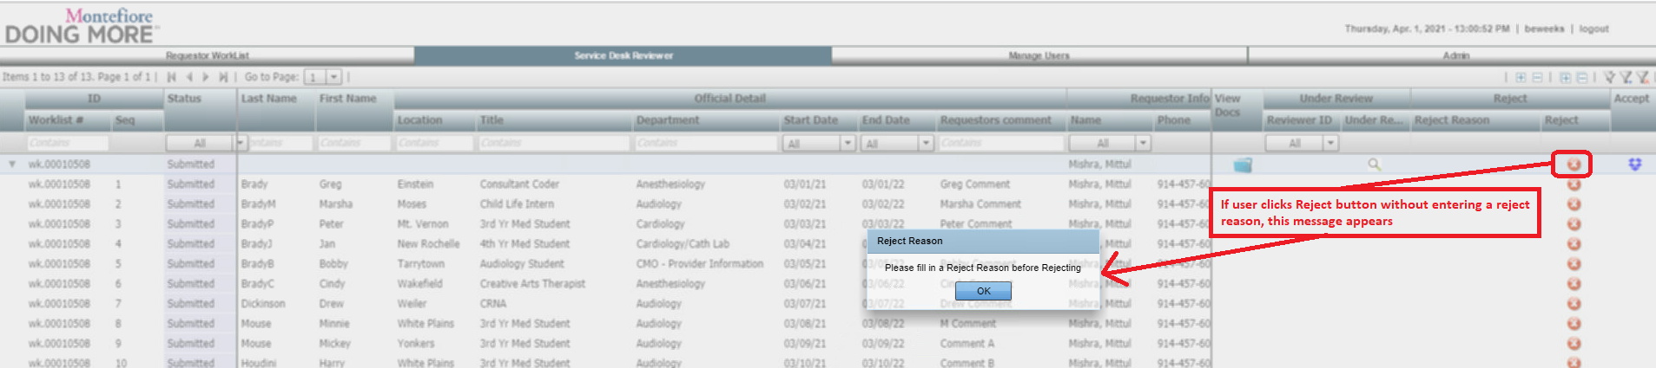

#### Request:

#### Response:

### Step 24: Reject Request

#### Example Screen:

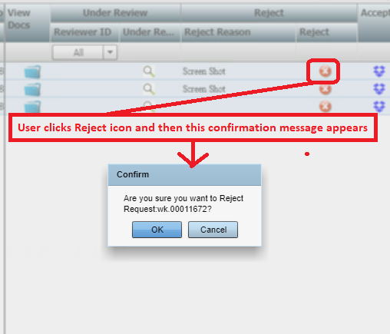

#### Request:

#### Response:

### Step 25: Accept Request

#### Example Screen:

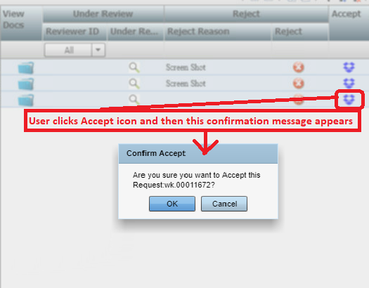

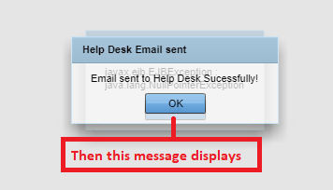

#### Request:

#### Response:

# MANAGE USERS TAB

### Step 26: Manage Users Tab

#### Example Screen:

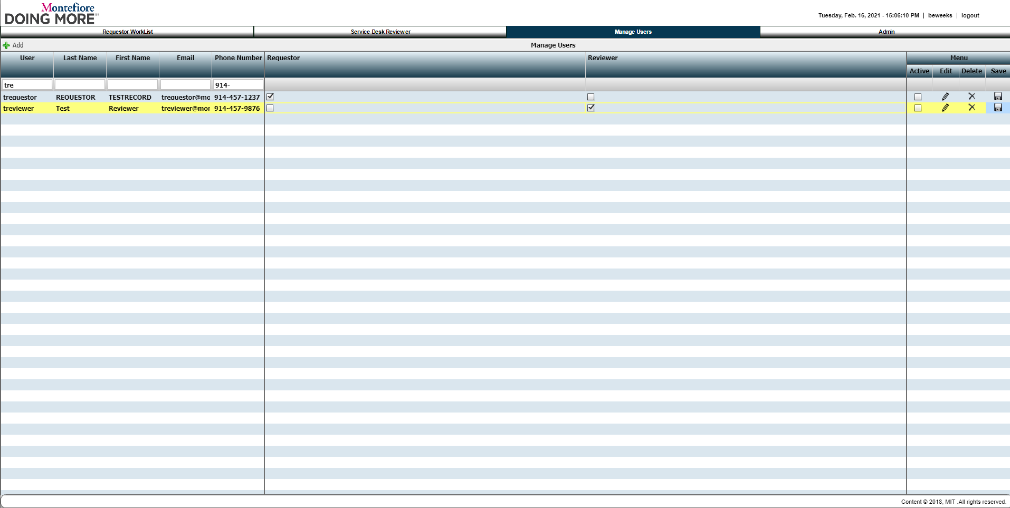

#### Request:

#### Response:

### Step 27: Add New User

#### Example Screen:

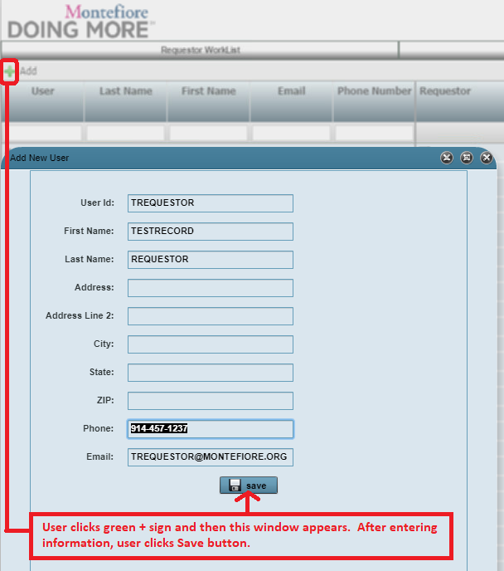

#### Request:

#### Response:

### Step 28: Edit Users

#### Example Screen:

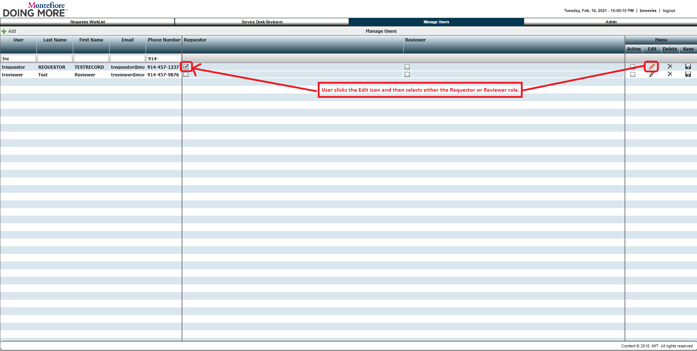

#### Request:

#### Response:

### Step 29: Cancel User Changes

#### Example Screen:

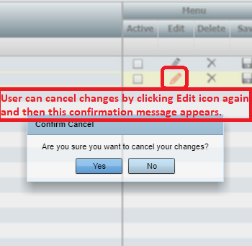

#### Request:

#### Response:

### Step 30: Save User

#### Example Screen:

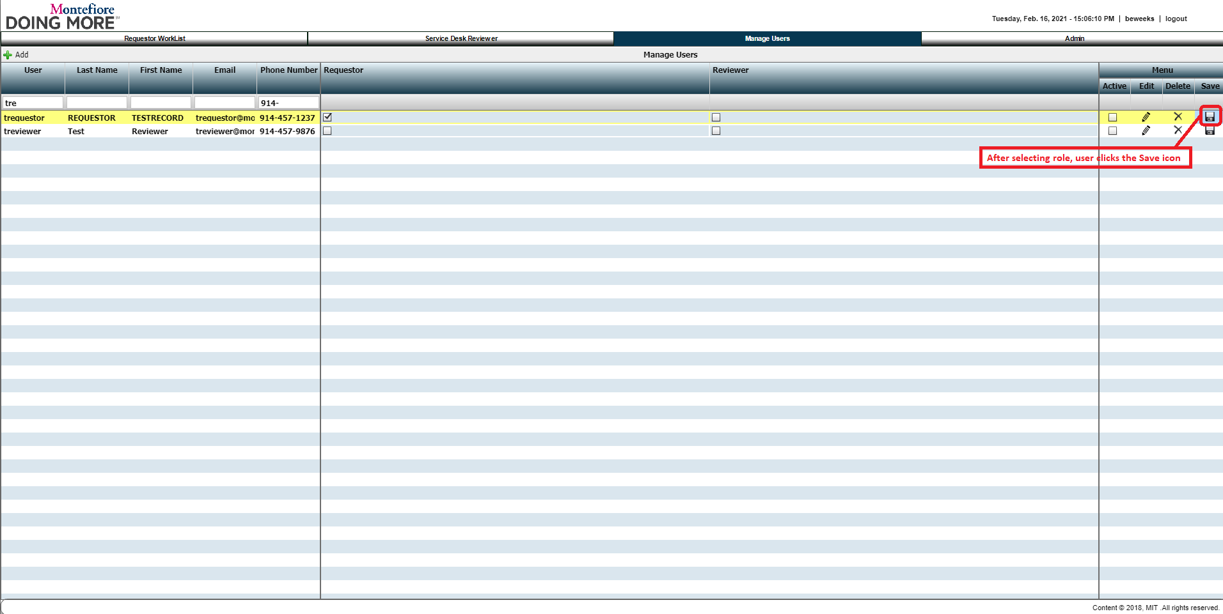

#### Request:

#### Response:

### Step 31: Activate User

#### Example Screen:

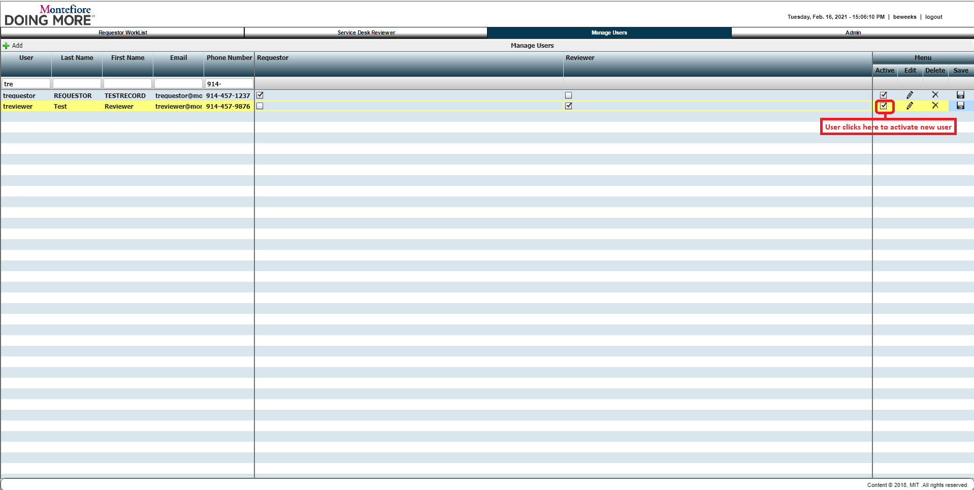

#### Request:

#### Response:

# ADMIN TABS/SUBTABS

## DEPARTMENTS SUBTAB

### Step 32: Departments Tab

#### Example Screen:

**Note: This screen should be modified to follow the same format as the Locations tab. A Green Plus sign icon should be added to this screen to allow users to add a new row.**

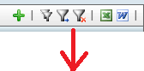

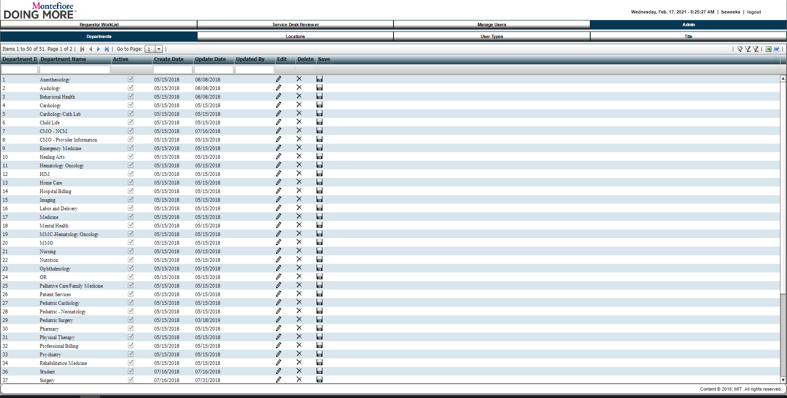

#### Request:

#### Response:

### Step 33: Edit Department

#### Example Screen:

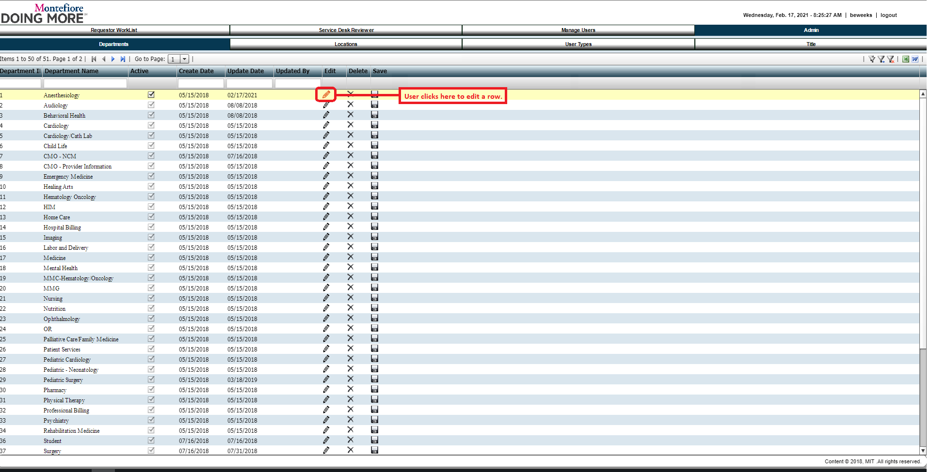

#### Request:

#### Response:

### Step 34: Cancel Department Edit

#### Example Screen:

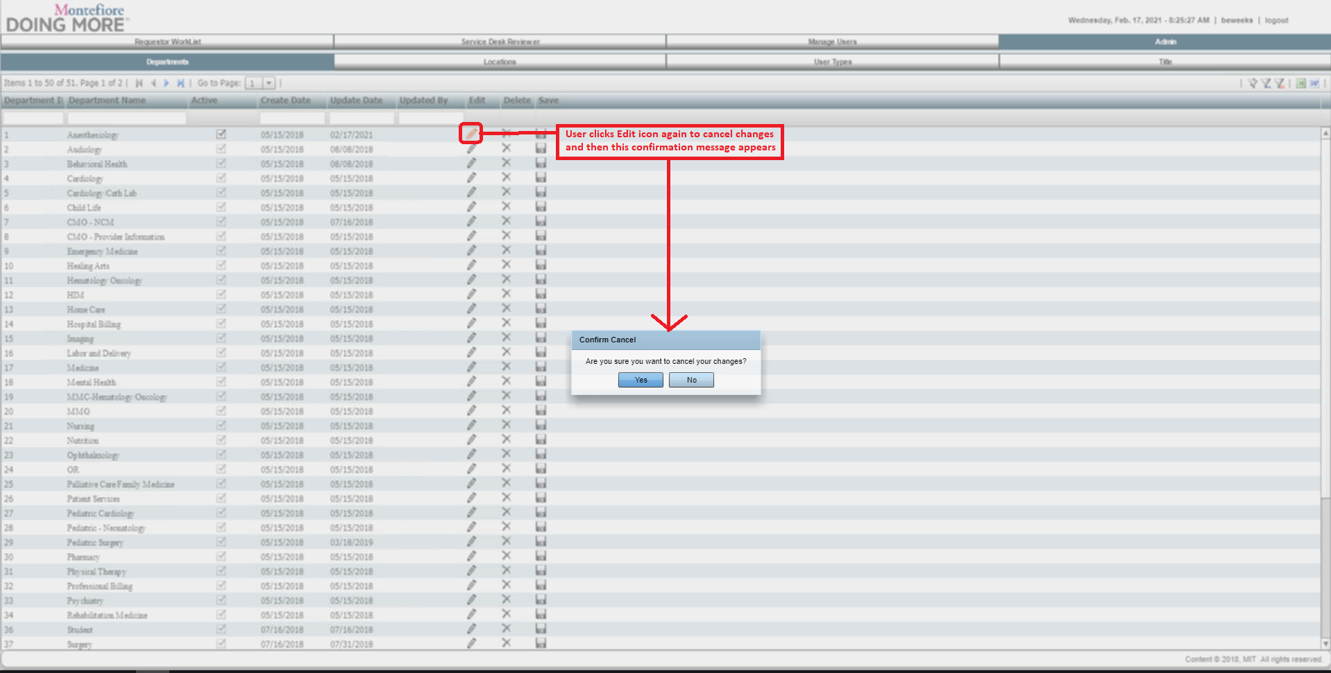

#### Request:

#### Response:

### Step 35: Save Department

#### Example Screen:

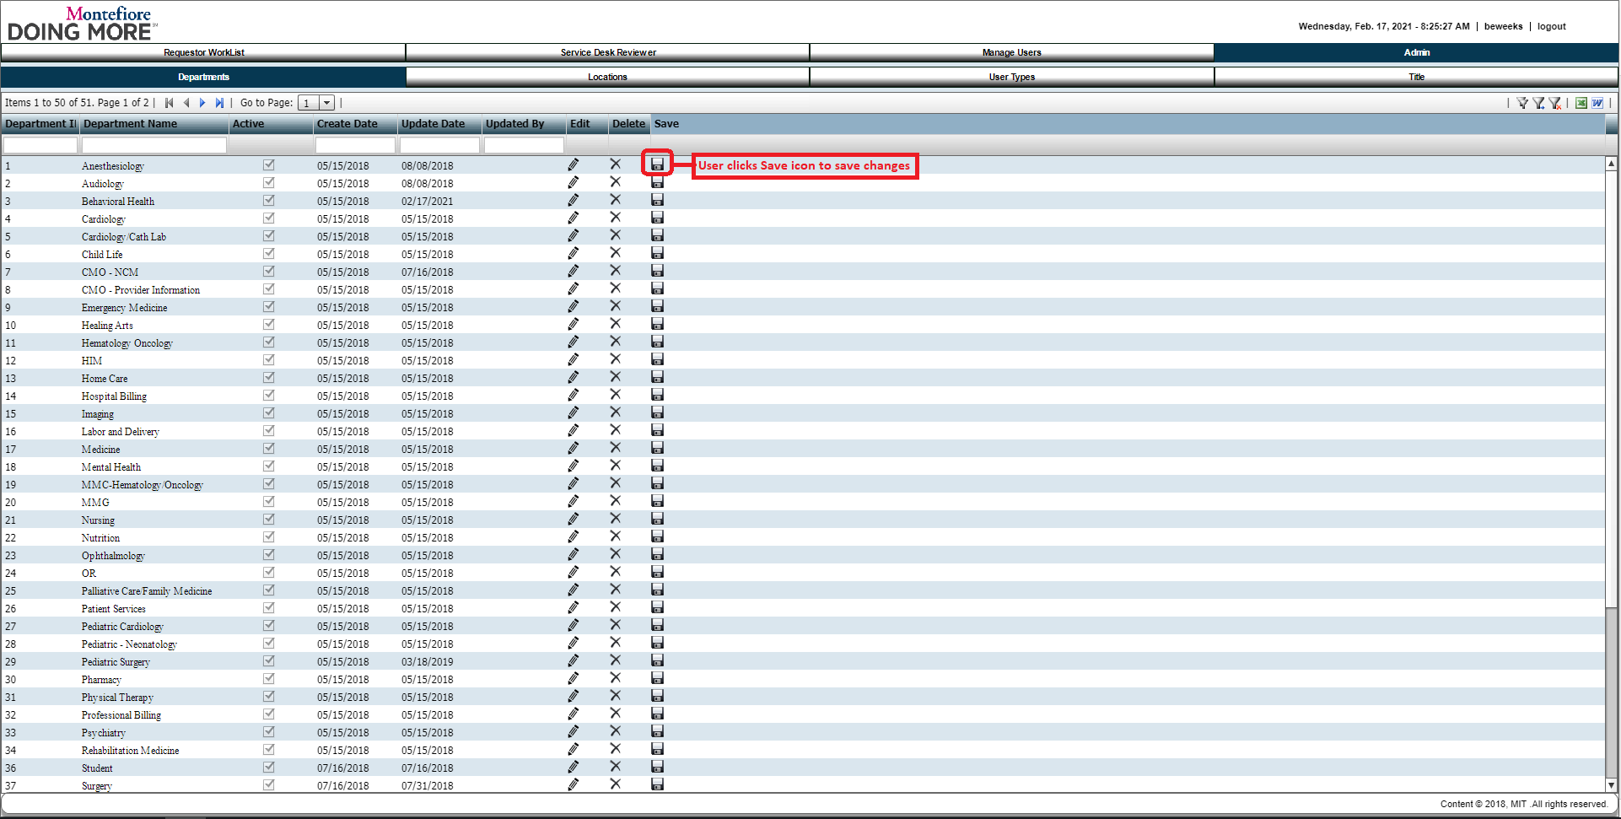

#### Request:

#### Response:

### Step 36: Delete Department

#### Example Screen:

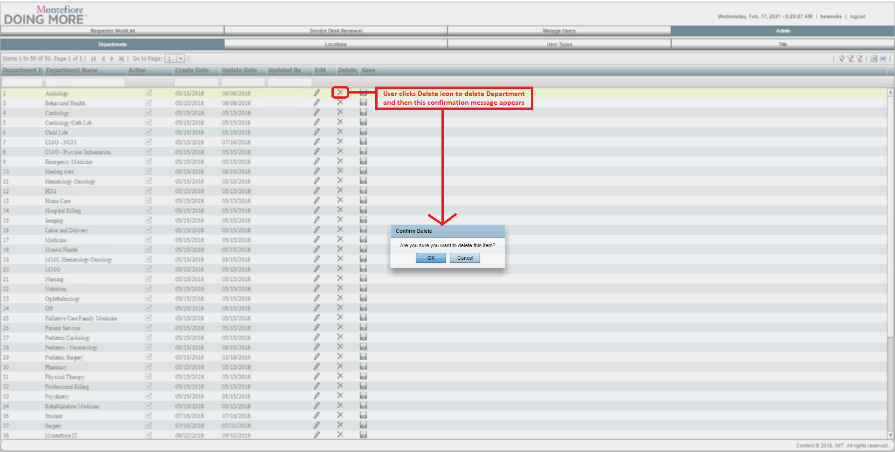

#### Request:

#### Response:

## LOCATIONS SUBTAB

### Step 37: Locations Tab

#### Example Screen:

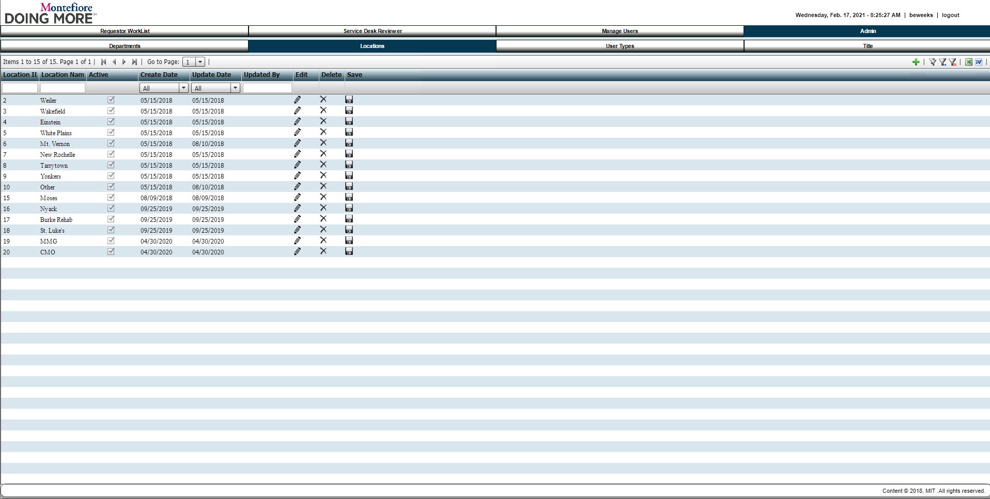

#### Request:

#### Response:

### Step 38: Edit Locations

#### Example Screen:

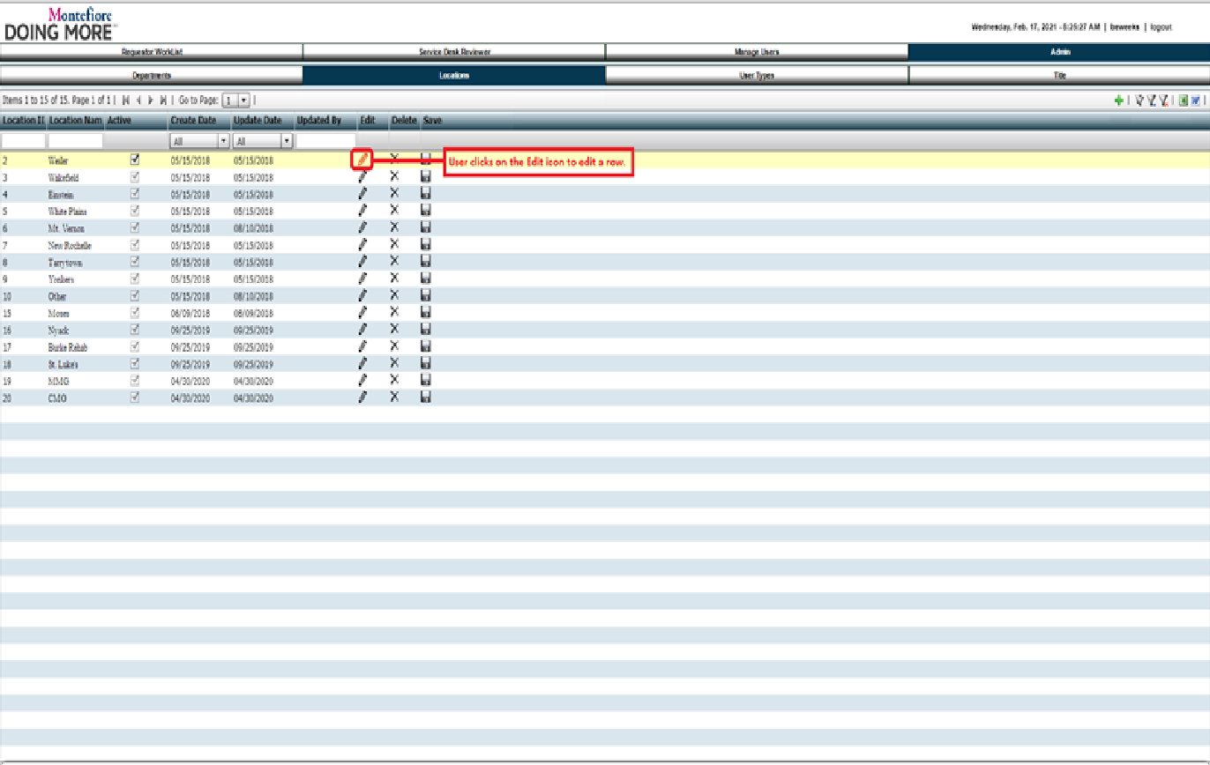

#### Request:

#### Response:

### Step 39: Cancel Location Edit

#### Example Screen:

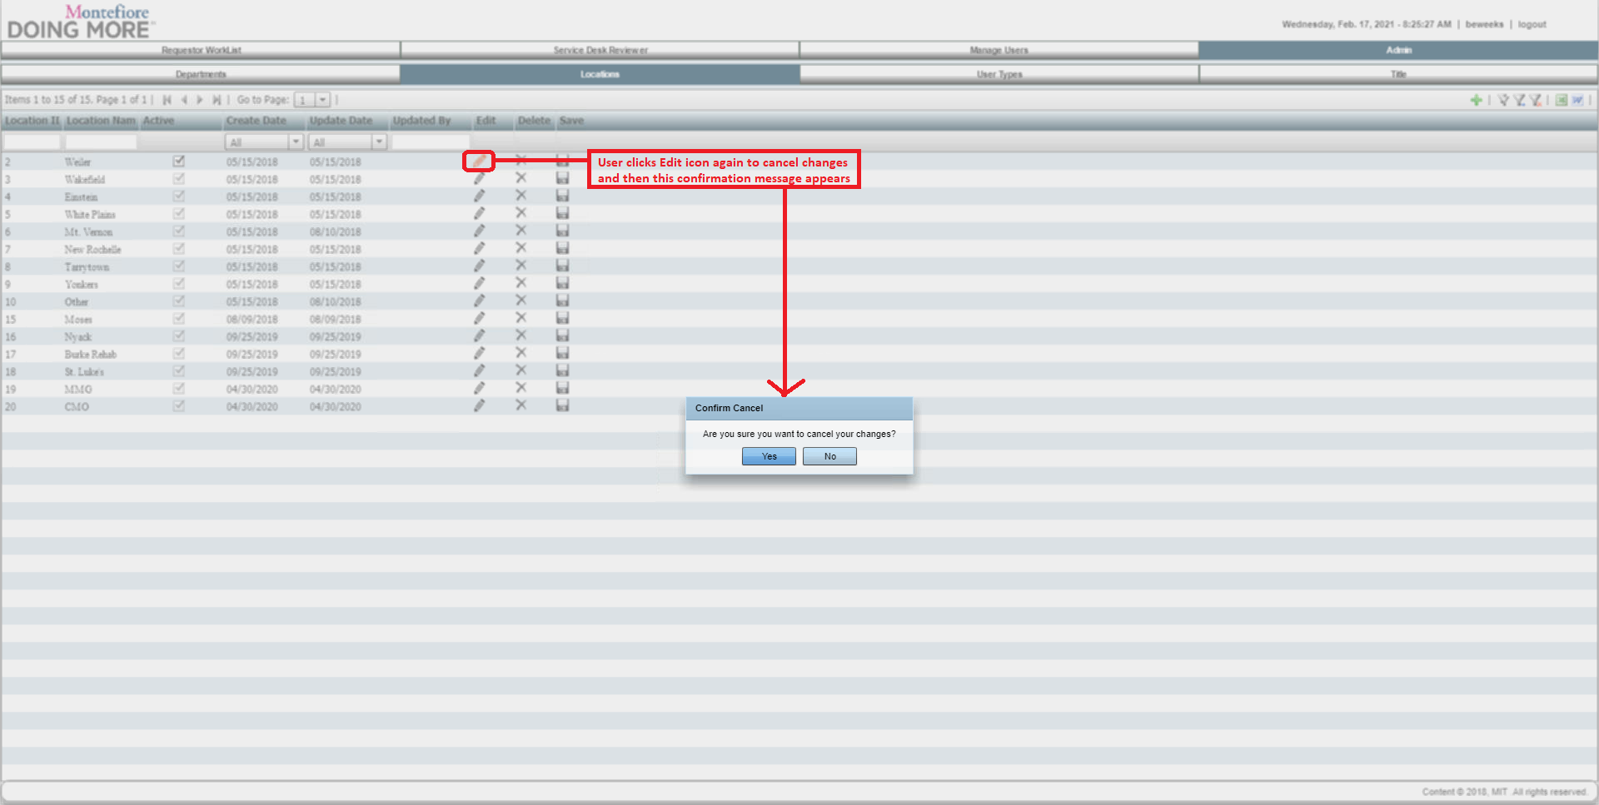

#### Request:

#### Response:

### Step 40: Save Location

#### Example Screen:

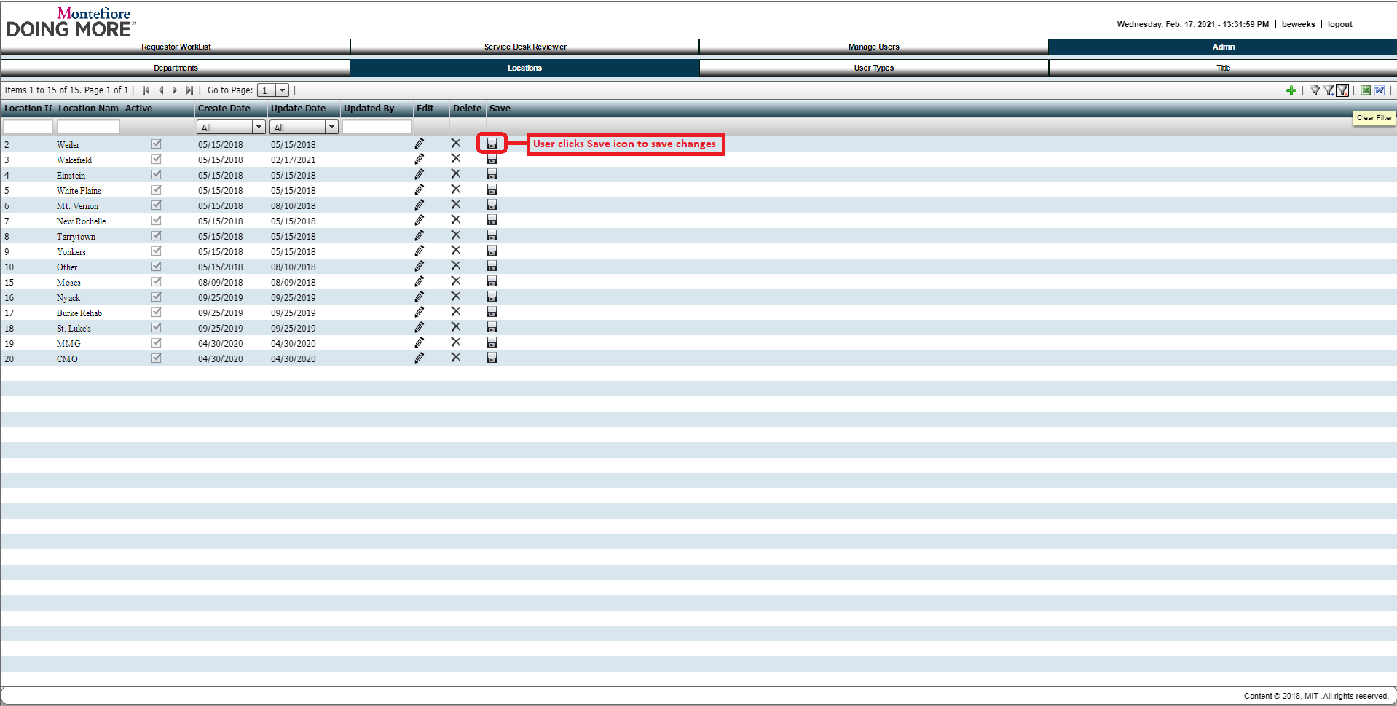

#### Request:

#### Response:

### Step 41: Delete Location

#### Example Screen:

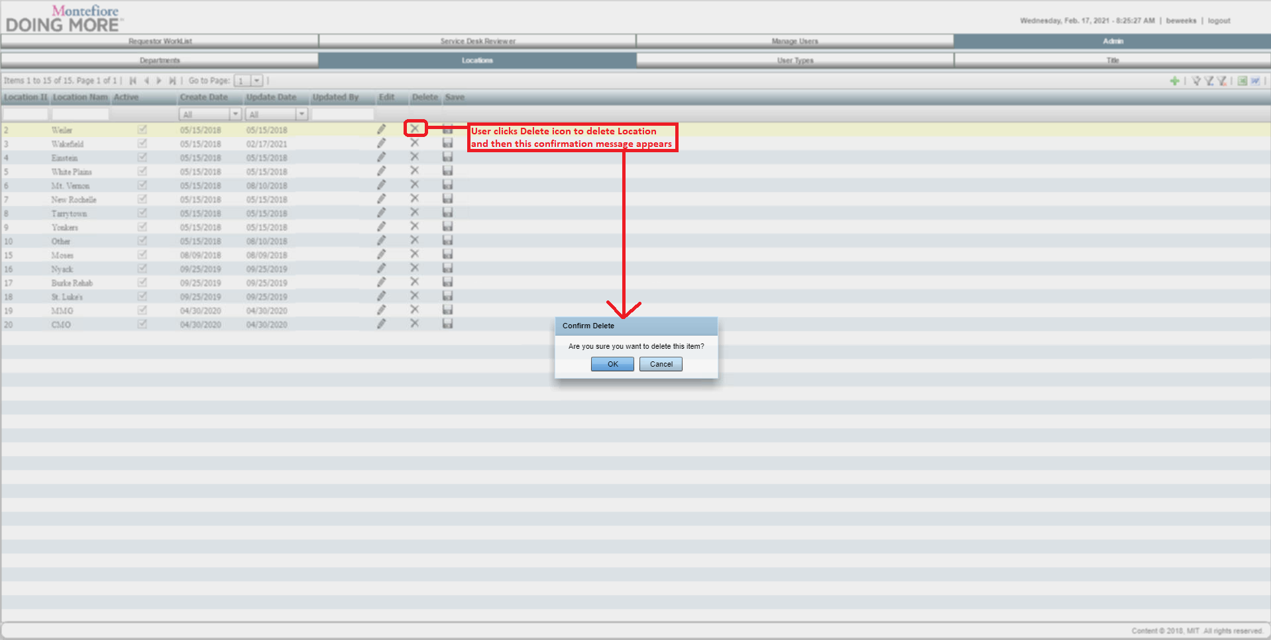

#### Request:

#### Response:

## USER TYPES SUBTAB

### Step 42: User Types Tab

#### Example Screen:

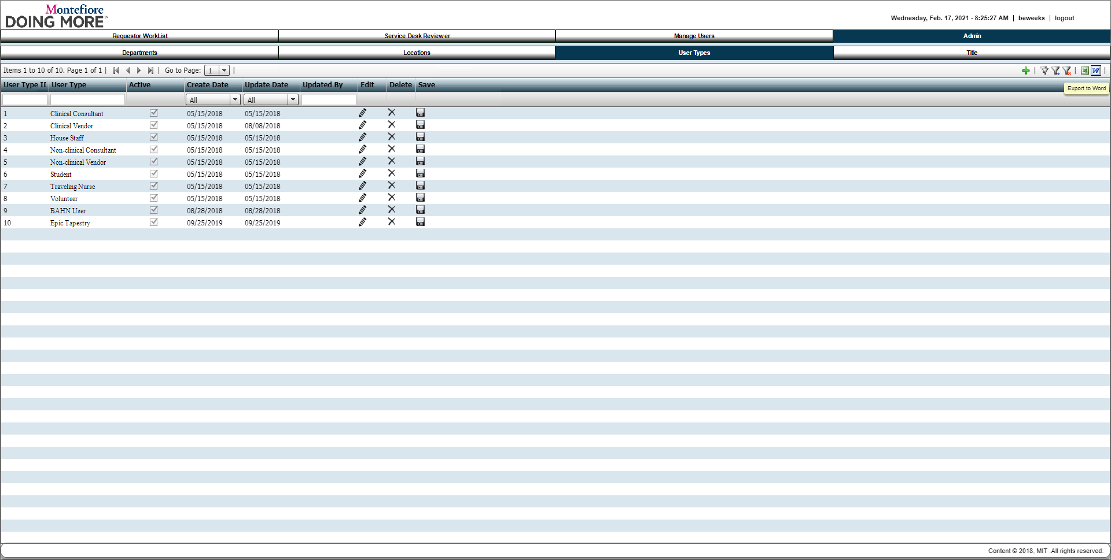

#### Request:

#### Response:

### Step 43: Edit User Types

#### Example Screen:

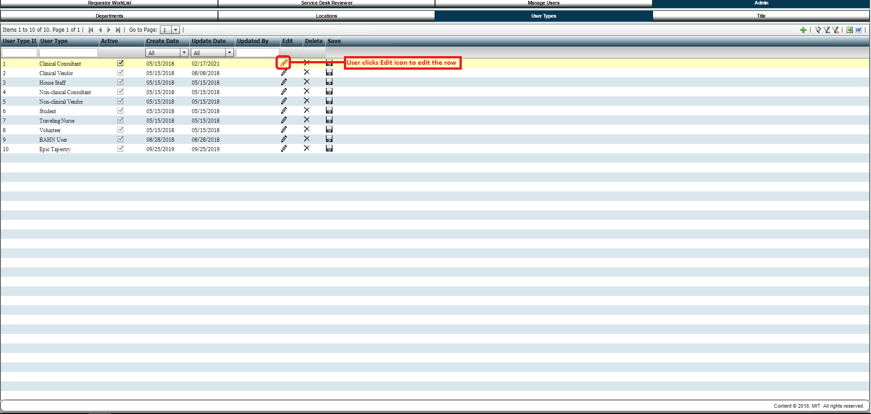

#### Request:

#### Response:

### Step 44: Cancel User Types Edit

#### Example Screen:

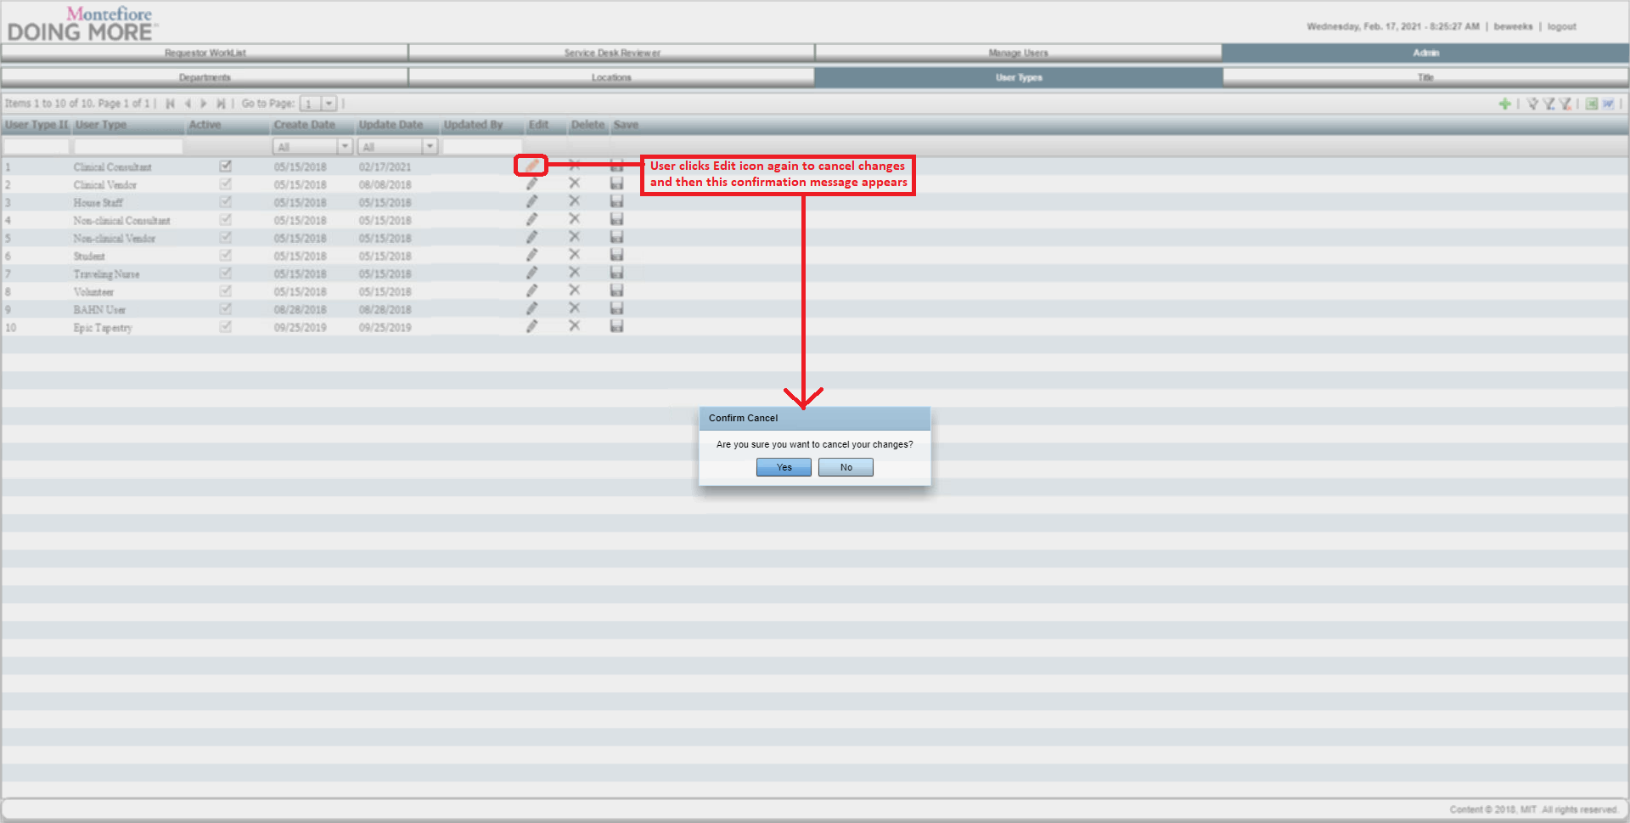

#### Request:

#### Response:

### Step 45: Save User Types

#### Example Screen:

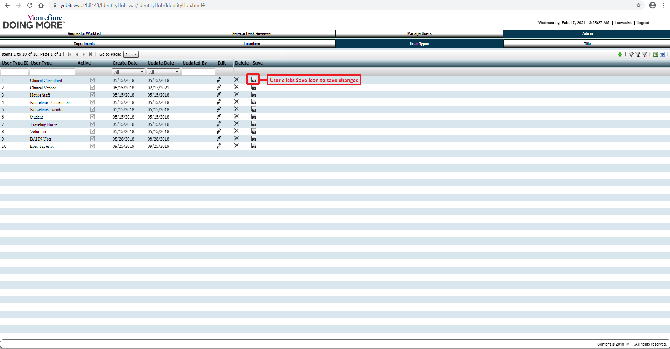

#### Request:

#### Response:

### Step 46: Delete User Types

#### Example Screen:

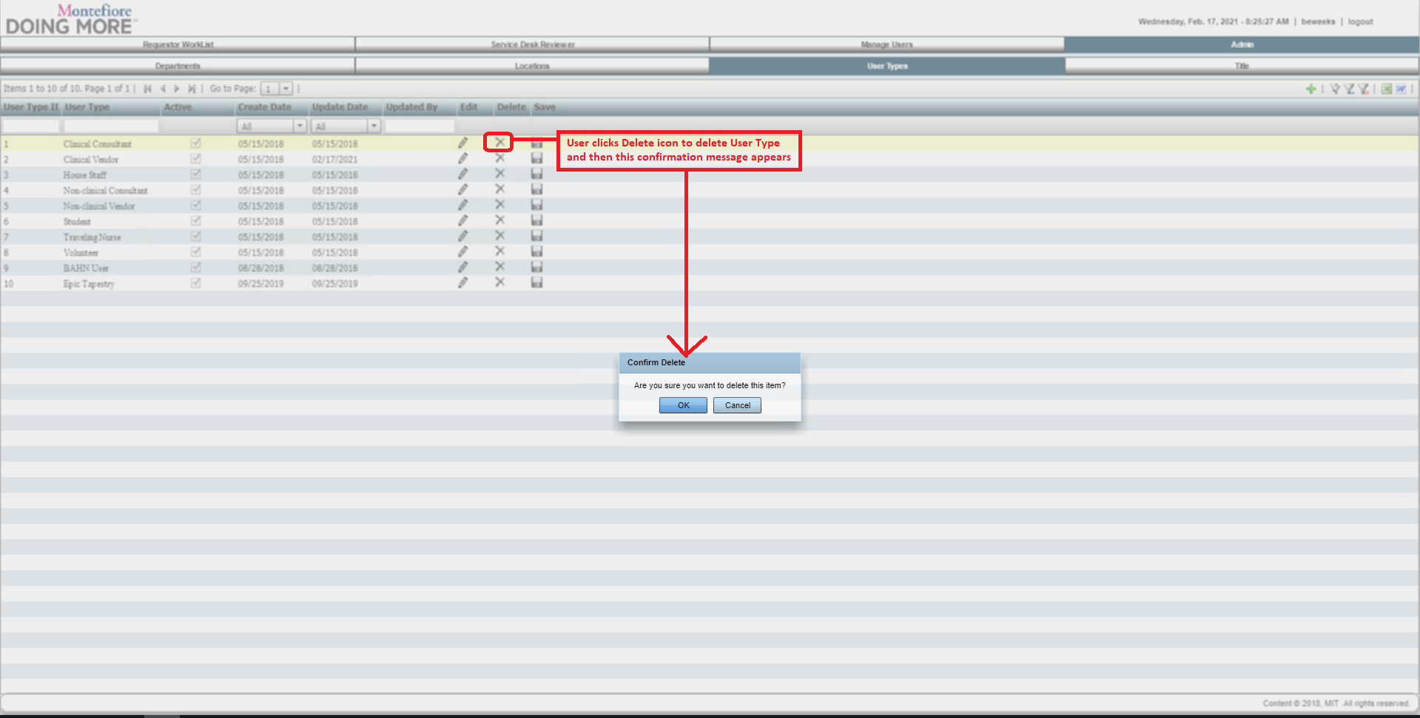

#### Request:

#### Response:

## TITLE SUBTAB

### Step 47: Title Tab

#### Example Screen:

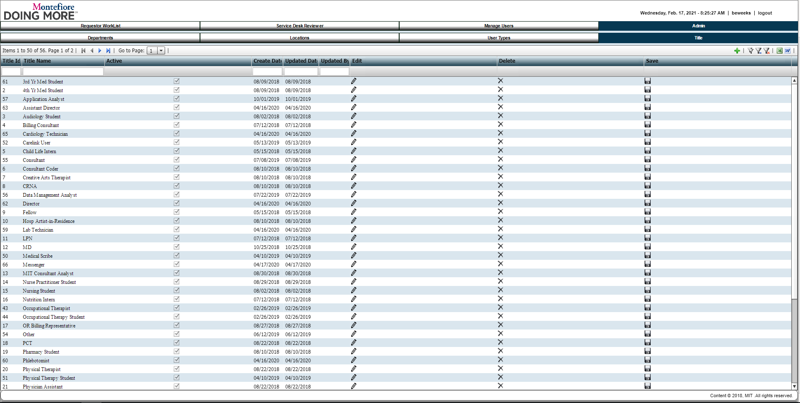

#### Request:

#### Response:

### Step 48: Edit Title

#### Example Screen:

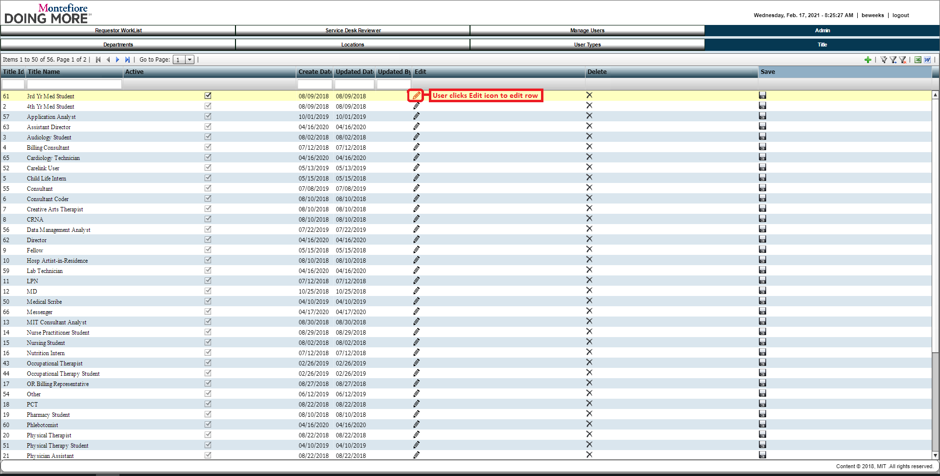

#### Request:

#### Response:

### Step 49: Cancel Title Edit

#### Example Screen:

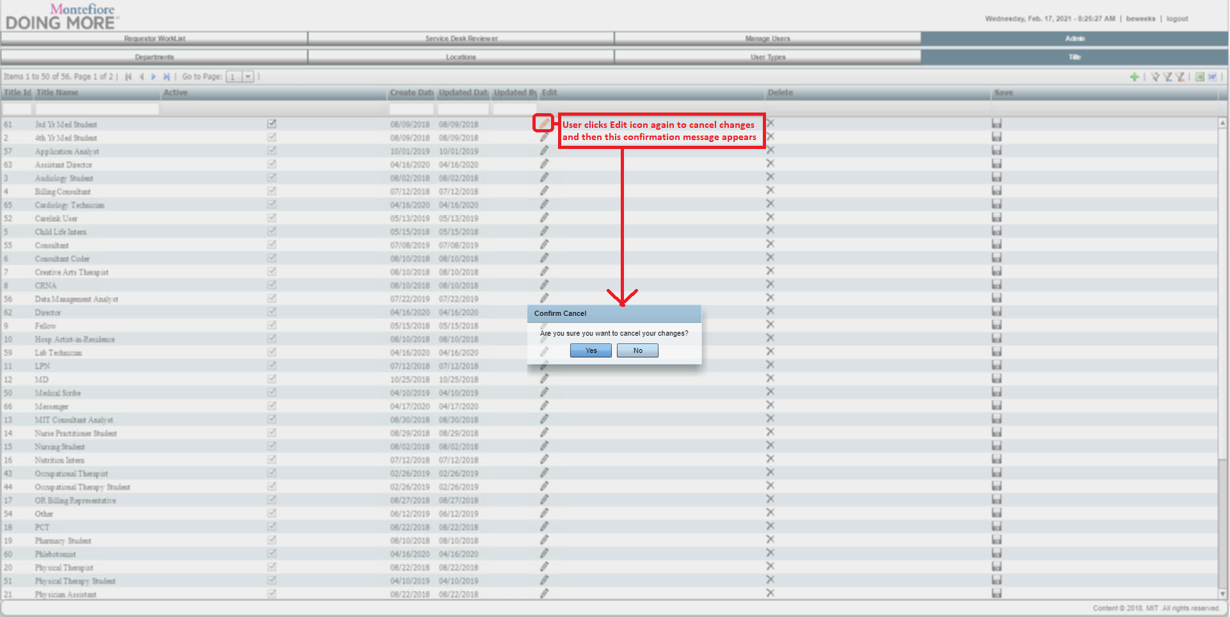

#### Request:

#### Response:

### Step 50: Save Title

#### Example Screen:

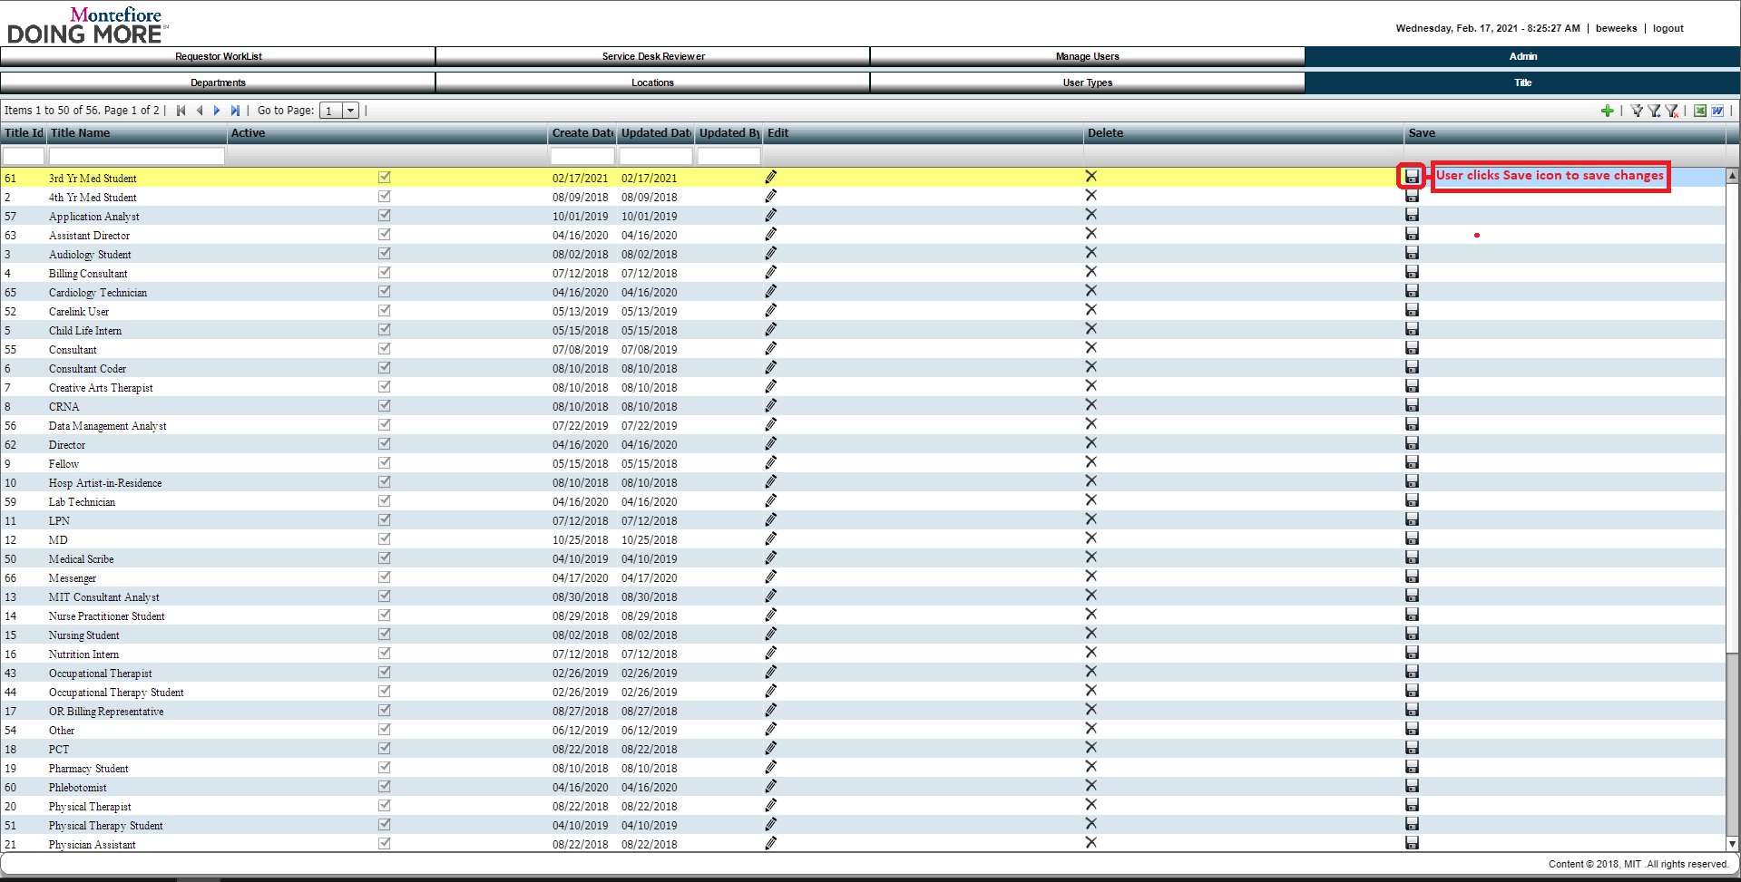

#### Request:

#### Response:

### Step 51: Delete Title

#### Example Screen:

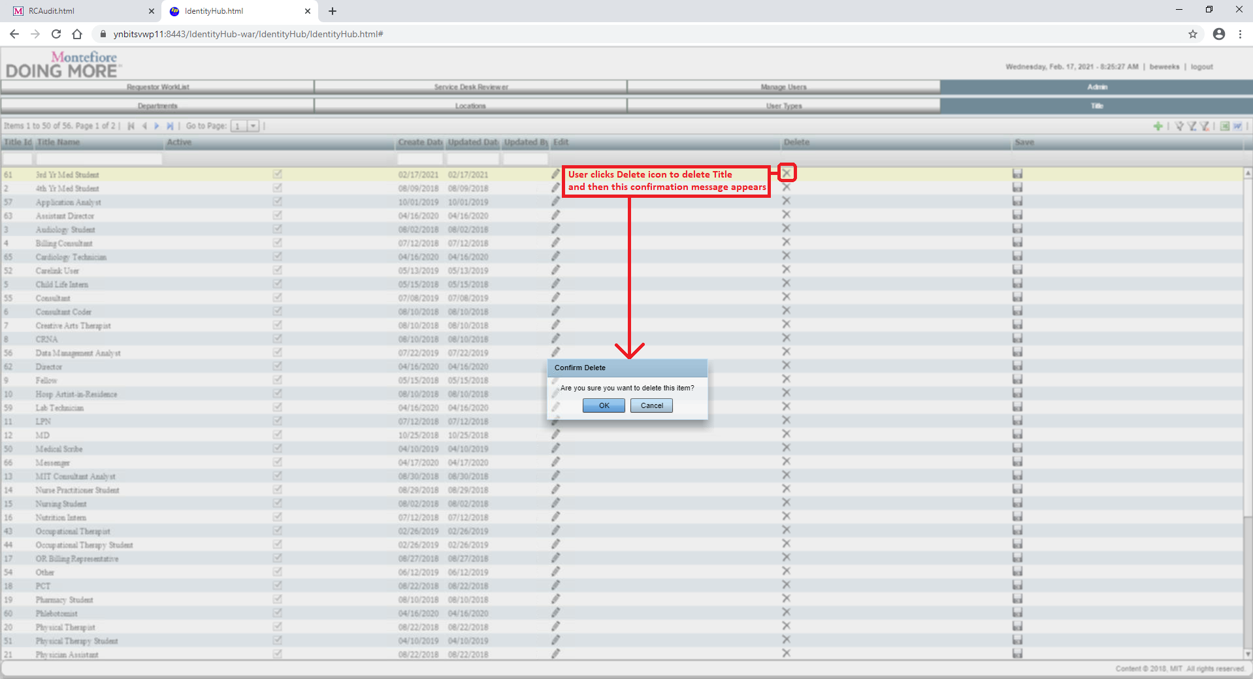

#### Request:

#### Response: